Farmer’s Wife Dinner Recipes
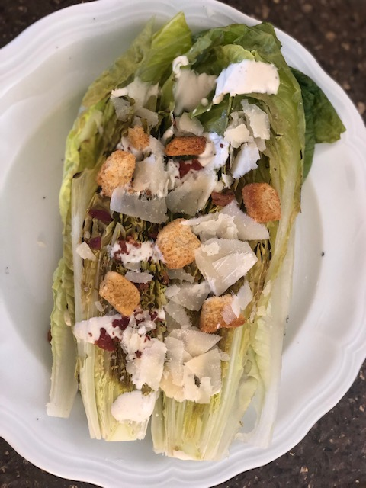
Caesar Romaine Heart Salad (John’s Favorite salad)
Ingredients:
Romaine Hearts sliced in half
Pecorino Romano Cheese
Creamy Caesar (Ken’s Steak House Dressing)
Bacon chopped up into pieces
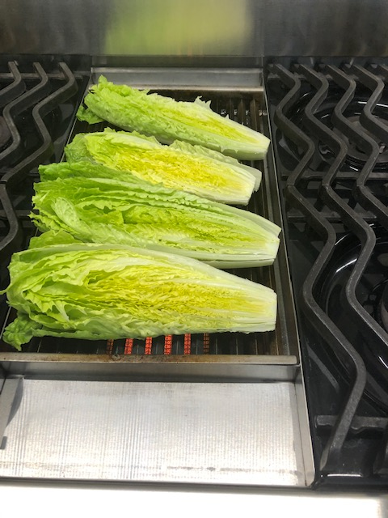
Caesar or garlic Croutons
Olive Oil

Directions:
- Remove stems and slice Romaine Heart lengthwise in half
- Lightly apply olive oil
- Grill Romaine directly on a hot grill for a couple of minutes on each side.
- Place on plate and top with a drizzle of dressing, sprinkle of bacon, cheese, and croutons.

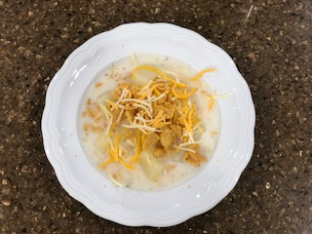
Potato Soup (My kid’s favorite)

Ingredients:
5lbs Russet potatoes
5-6 cups of water
5-6 teaspoons of Knorr Chicken Flavor Bouillon
2-3 cups of milk
1 teaspoon salt
½ teaspoon pepper
1 family size bag of Frito Chips
2 cups of shredded Colby Cheese

Directions:
- Peel potatoes, cut into large pieces.
- Place potatoes into 8qt saucepan. Measuring the amount of water by cups, fill with enough water to just cover the potatoes. Mine is usually 5 cups. Add 1 teaspoon of Chicken flavoring for every cup of water you added. Heat to a boil over high heat, stirring occasionally. Once mixture is boiling, reduce heat just enough so mixture bubble gently. Cover and cook for about 15mins or until potatoes are tender when pierced with a fork.
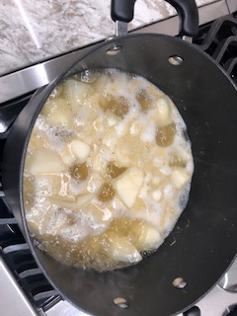
- When potatoes are done, remove the saucepan from the heat, but do not drain. Break potatoes into smaller pieces with a fork. The mixture should still be lumpy.
- Stir in pepper, salt, and ¾ cup of milk for ever cup of water added in step 2. (5 cups water = 3 ¾ cup of milk.)
- You can serve it at this temperature or heat a second time over medium heat, stirring occasionally, until hot and steaming, but do not let the soup boil.
- We like to add, at the table, cheese and crush Fritos over the top.

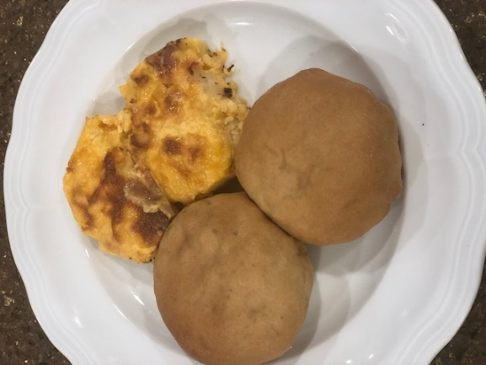
Runzas (Boelts Family Tradition)
Serving size: 1-2, makes about 48.
Prep Time: 5-6 Hours Bread Rising, + 2-3 Hours
Cook Time: 30-45 mins each batch
Ingredients:
5 lbs Hamburger (browned)
2-3lbs cabbage (cut finely)
1 Sweet Onion (cut finely)
2 teaspoons pepper
2 tablespoons salt
48 frozen bread dough rolls Rose White Bread
½ cup- one stick of butter

Directions:
Hint: Mix is easier to manage if you make it in two batches. Each with 2.5lbs ground beef, ½ cabbage, ½ onion, 24 rolls, and ¼ a stick of butter.
- Let bread dough rise according to directions on package.
- Chop cabbage very, very fine.
- Chop onion very fine.
- Once bread has raised, prepare seamer to steam cabbage.
- Steam cabbage while browning hamburger.
- Drain fat from hamburger. Add onion and cook.
- Mix while hot. Cooked hamburger and onion, cooked cabbage, add salt and pepper.
- Roll out dough, thinly making about a 7” circle. Spoon in about ½ to ¾ cup hamburger/onion/cabbage mix. Bring together and pinch sides of dough shut.
- Turn dough pocket over onto greased cookie sheet. Continue same procedure.
- Let it rise a second time for about 20mins.
- Bake 350* oven until golden brown 35-40mins
- Remove and using a stick of butter, apply butter to tops
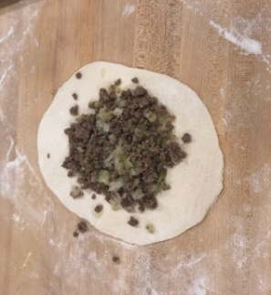 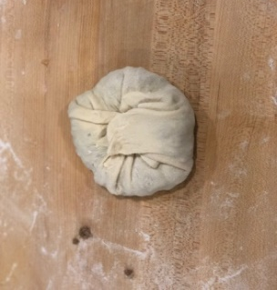 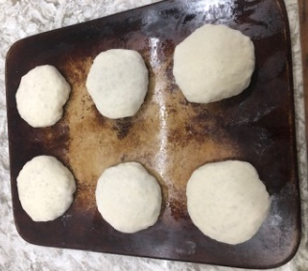 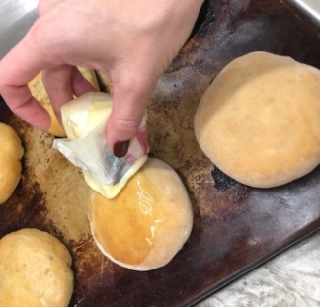 To Freeze: Let cool for about 30min-1 hour. Place on cook sheets in freezer. One completely frozen, store in a Ziploc bag removing air.
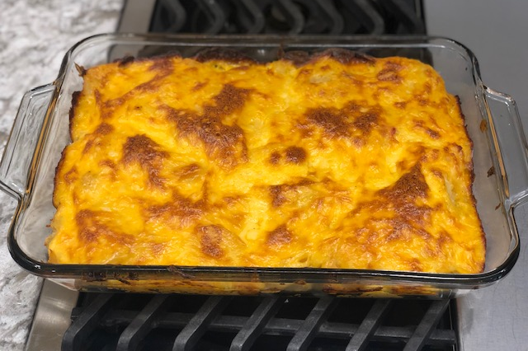
AU GRATIN POTATOES
Serving size: 12 Servings (1/2 cup)
Prep Time: 45mins
Cook Time: 45mins-1 hour

Ingredients:
6 potatoes
¼ cup chopped pimento or jarred
¾ teaspoon salt
Pepper to taste
Sause:
4 tablespoon of butter
2 cups milk
8 oz Cracker Barrel Sharp Cheddar
4 tablespoons cornstarch

Directions:
- Boil potatoes. Peel and slice when cool
- In a greased 9x13 pan layer sliced potatoes placing pimento, salt, and pepper between layers.
Sause:
- Cook milk and corn starch, when hot add butter and cheese. Melt cheese.
- Pour over potatoes.
- Bake with no cover at 325*F for 45mins-1 hour

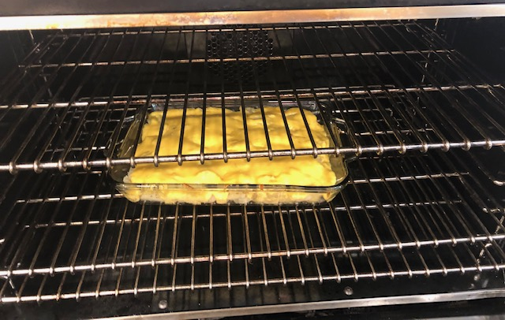

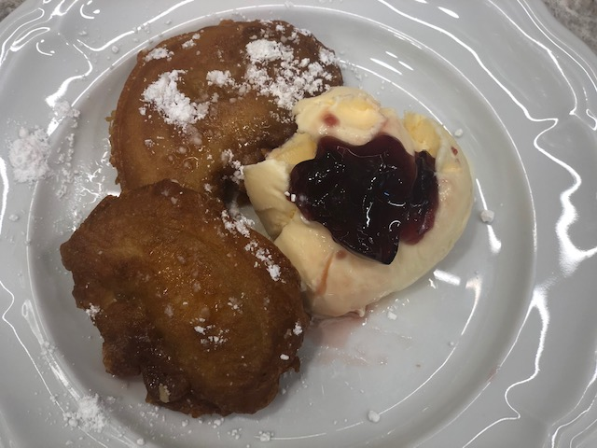
French Toast/ Peach Fritters
(Rice Family Tradition)
-
Ingredients:
1 cup flour
½ teaspoon salt
1 teaspoon baking powder
2 eggs beaten
1 tablespoon Crisco Oil
½ cups milk +2 to 3 tablespoons more if needed
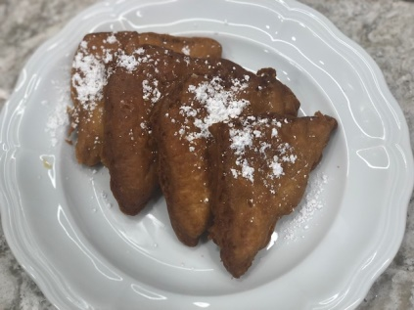
Canned peaches and pineapples (Drained and dried on a paper towel)
Bread if making French toast
Vegetable Oil
Powder Sugar

Directions:
- Heat vegetable oil to 375*F.
- To make batter combine: Flour, salt, baking powder, eggs, 1 tablespoon Crisco Oil, milk
- Take fruit and drench in batter.
- Cook in hot oil, turn over, cook until golden brown
- Remove and drain on a paper towel
- Place on plate and sprinkle with powder sugar.
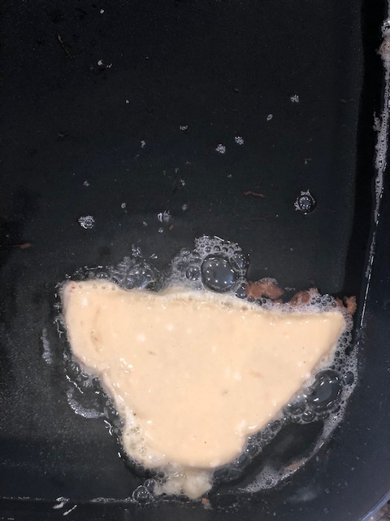
Sandhill Cherry Jam
Made from wild Cherry Bushes in Nebraska
Ingredients:
9.5 cups sand-cherry Juice
13.5 cups sugar
2 pks Sure Jelly Fruit Pectin

Directions:
- Bring juice to a boil
- Add the 2pks Sure Jell
- Add Sugar
- Bring all to a boil and boil hard for 8 mins stirring constantly. (Will have a foam on top, remove foam with metal spoon)
- Fill jars and seal with a water bath.
Alicia’s Fudge
(Family tradition for over 20 years)
Serving size: 8 ounces, makes about 7 containers
Prep Time: 10 mins Cook Time: 25 mins

Ingredients:
4 Cups Sugar
1 2/3 Cups Evaporated Milk
1 cup butter
2 cups semisweet chocolate pieces
7 oz jar marshmallow
1 cup chopped walnuts (optional)
1 teaspoon vanilla

Directions:
- Butter sides of a heavy 3 quart saucepan. Combine sugar, remaining butter, and evaporated milk.
- Cook and stir over medium heat till mixture boils. Reduce heat to medium and continue cooking and stirring for 8-10 mins. You will see the color and texture change. Temperature will be just under 229, or right before Soft ball.
- Remove pan from heat continuing to stir while mix in chocolate pieces. Then, mix in marshmallow with Vanilla. I usually have all this opened and pre pour the vanilla into the marshmallow jar. Last, add in nuts if using.
- Continue to stir for a few mins prior to pouring into containers. This really just allows you to bring the temperature down and not melt the containers.

